# INDIA GENERAL ELECTIONS RESULT ANALYSIS 2024

### Schema Diagram

### Total Seats:

SELECT COUNT (DISTINCT "Parliament Constituency") as Total_Seats

FROM constituencywise_results;

Results :  
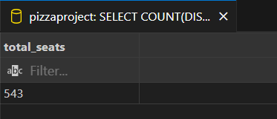

Total Seats by State   
  
SELECT

    states.state,

    COUNT(DISTINCT constituencywise_results."Parliament Constituency") AS Total_Seats

FROM

    constituencywise_results

INNER JOIN

    statewise_results

    ON constituencywise_results."Parliament Constituency" = statewise_results."Parliament Constituency"

INNER JOIN

    states

    ON statewise_results."State ID" = states."State ID"

GROUP BY

    states.state;

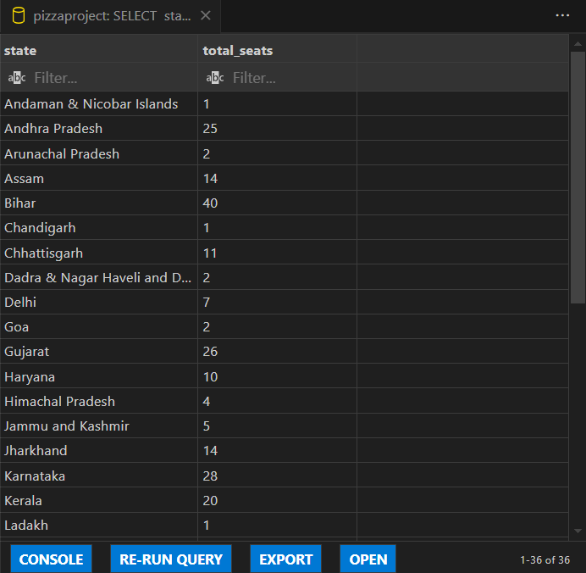

Total Seats Won by NDA Alliance   
  
SELECT

    SUM(CASE

            WHEN party IN (

                'Bharatiya Janata Party - BJP',

                'Telugu Desam - TDP',

                'Janata Dal (United) - JD(U)',

                'Shiv Sena - SHS',

                'AJSU Party - AJSUP',

                'Apna Dal (Soneylal) - ADAL',

                'Asom Gana Parishad - AGP',

                'Hindustani Awam Morcha (Secular) - HAMS',

                'Janasena Party - JnP',

                'Janata Dal (Secular) - JD(S)',

                'Lok Janshakti Party(Ram Vilas) - LJPRV',

                'Nationalist Congress Party - NCP',

                'Rashtriya Lok Dal - RLD',

                'Sikkim Krantikari Morcha - SKM'

            ) THEN Won

            ELSE 0

        END) AS NDA_Total_Seats_Won

FROM

    partywise_results;

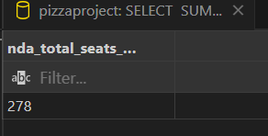  
  
  
Seats won by NDA Alliance Parties  
  
SELECT

    party as Party_Name,

    won as Seats_Won

FROM

    partywise_results

WHERE

    party IN (

        'Bharatiya Janata Party - BJP',

        'Telugu Desam - TDP',

        'Janata Dal  (United) - JD(U)',

        'Shiv Sena - SHS',

        'AJSU Party - AJSUP',

        'Apna Dal (Soneylal) - ADAL',

        'Asom Gana Parishad - AGP',

        'Hindustani Awam Morcha (Secular) - HAMS',

        'Janasena Party - JnP',

        'Janata Dal  (Secular) - JD(S)',

        'Lok Janshakti Party(Ram Vilas) - LJPRV',

        'Nationalist Congress Party - NCP',

        'Rashtriya Lok Dal - RLD',

        'Sikkim Krantikari Morcha - SKM'

    )

ORDER BY Seats_WonDESc

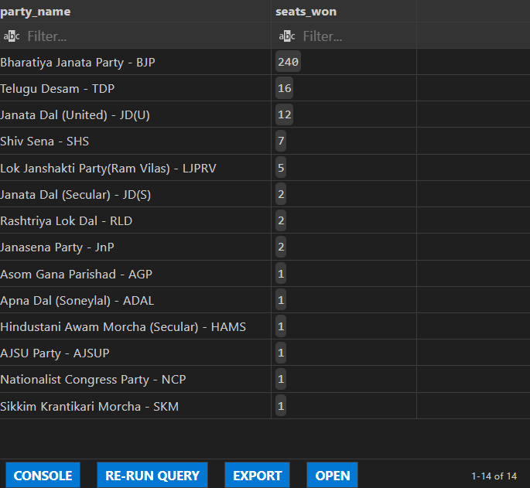

Seats won by I.N.D.I.A Alliance Parties  
  
SELECT

    party as Party_Name,

    won as Seats_Won

FROM

    partywise_results

WHERE

    party IN (

        'Indian National Congress - INC',

                'Aam Aadmi Party - AAAP',

                'All India Trinamool Congress - AITC',

                'Bharat Adivasi Party - BHRTADVSIP',

                'Communist Party of India  (Marxist) - CPI(M)',

                'Communist Party of India  (Marxist-Leninist)  (Liberation) - CPI(ML)(L)',

                'Communist Party of India - CPI',

                'Dravida Munnetra Kazhagam - DMK',

                'Indian Union Muslim League - IUML',

                'Nat`Jammu & Kashmir National Conference - JKN',

                'Jharkhand Mukti Morcha - JMM',

                'Jammu & Kashmir National Conference - JKN',

                'Kerala Congress - KEC',

                'Marumalarchi Dravida Munnetra Kazhagam - MDMK',

                'Nationalist Congress Party Sharadchandra Pawar - NCPSP',

                'Rashtriya Janata Dal - RJD',

                'Rashtriya Loktantrik Party - RLTP',

                'Revolutionary Socialist Party - RSP',

                'Samajwadi Party - SP',

                'Shiv Sena (Uddhav Balasaheb Thackrey) - SHSUBT',

                'Viduthalai Chiruthaigal Katchi - VCK'

    )

ORDER BY Seats_Won DESC

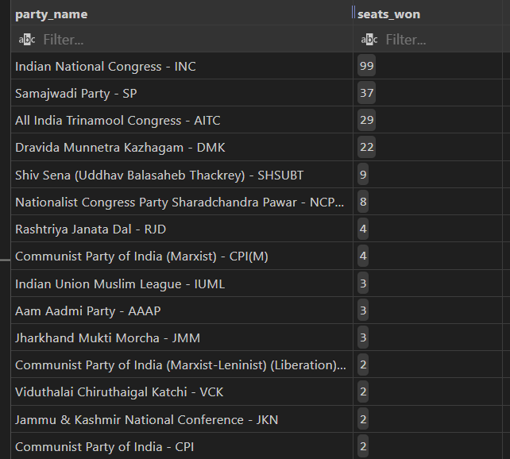  
  
  
Total seats won By I.N.D.I.A   
  
SELECT

    SUM(CASE

            WHEN party IN (

                'Indian National Congress - INC',

                'Aam Aadmi Party - AAAP',

                'All India Trinamool Congress - AITC',

                'Bharat Adivasi Party - BHRTADVSIP',

                'Communist Party of India  (Marxist) - CPI(M)',

                'Communist Party of India  (Marxist-Leninist)  (Liberation) - CPI(ML)(L)',

                'Communist Party of India - CPI',

                'Dravida Munnetra Kazhagam - DMK',

                'Indian Union Muslim League - IUML',

                'Nat`Jammu & Kashmir National Conference - JKN',

                'Jharkhand Mukti Morcha - JMM',

                'Jammu & Kashmir National Conference - JKN',

                'Kerala Congress - KEC',

                'Marumalarchi Dravida Munnetra Kazhagam - MDMK',

                'Nationalist Congress Party Sharadchandra Pawar - NCPSP',

                'Rashtriya Janata Dal - RJD',

                'Rashtriya Loktantrik Party - RLTP',

                'Revolutionary Socialist Party - RSP',

                'Samajwadi Party - SP',

                'Shiv Sena (Uddhav Balasaheb Thackrey) - SHSUBT',

                'Viduthalai Chiruthaigal Katchi - VCK'

            ) THEN Won

            ELSE 0

        END) AS INDIA_Total_Seats_Won

FROM

    partywise_results

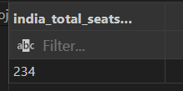

Add new column field in table partywise_results to get the Party Allianz

ALTER TABLE partywise_results

ADD party_alliance VARCHAR(50);

**I.N.D.I.A Allianz**

UPDATE partywise_results

SET party_alliance = 'I.N.D.I.A'

WHERE party IN (

'Indian National Congress - INC',

'Aam Aadmi Party - AAAP',

'All India Trinamool Congress - AITC',

'Bharat Adivasi Party - BHRTADVSIP',

'Communist Party of India (Marxist) - CPI(M)',

'Communist Party of India (Marxist-Leninist) (Liberation) - CPI(ML)(L)',

'Communist Party of India - CPI',

'Dravida Munnetra Kazhagam - DMK',

'Indian Union Muslim League - IUML',

'Jammu & Kashmir National Conference - JKN',

'Jharkhand Mukti Morcha - JMM',

'Kerala Congress - KEC',

'Marumalarchi Dravida Munnetra Kazhagam - MDMK',

'Nationalist Congress Party Sharadchandra Pawar - NCPSP',

'Rashtriya Janata Dal - RJD',

'Rashtriya Loktantrik Party - RLTP',

'Revolutionary Socialist Party - RSP',

'Samajwadi Party - SP',

'Shiv Sena (Uddhav Balasaheb Thackrey) - SHSUBT',

'Viduthalai Chiruthaigal Katchi - VCK'

);

**NDA Allianz**

UPDATE partywise_results

SET party_alliance = 'NDA'

WHERE party IN (

'Bharatiya Janata Party - BJP',

'Telugu Desam - TDP',

'Janata Dal (United) - JD(U)',

'Shiv Sena - SHS',

'AJSU Party - AJSUP',

'Apna Dal (Soneylal) - ADAL',

'Asom Gana Parishad - AGP',

'Hindustani Awam Morcha (Secular) - HAMS',

'Janasena Party - JnP',

'Janata Dal (Secular) - JD(S)',

'Lok Janshakti Party(Ram Vilas) - LJPRV',

'Nationalist Congress Party - NCP',

'Rashtriya Lok Dal - RLD',

'Sikkim Krantikari Morcha - SKM'

);

**OTHER**

UPDATE partywise_results

SET party_alliance = 'OTHER'

WHERE party_alliance IS NULL;

### Which party alliance (NDA, I.N.D.I.A, or OTHER) won the most seats across all states?

SELECT

p.party_alliance,

COUNT(cr.Constituency_ID) AS Seats_Won

FROM

constituencywise_results cr

JOIN

partywise_results p ON cr.Party_ID = p.Party_ID

WHERE

p.party_alliance IN ('NDA', 'I.N.D.I.A', 'OTHER')

GROUP BY

p.party_alliance

ORDER BY

Seats_Won DESC;

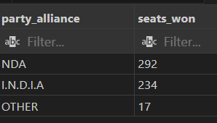

Winning candidate's name, their party name, total votes, and the margin of victory for a specific state and constituency  
  
  
SELECT cr.Winning_Candidate, p.Party, p.party_alliance, cr.Total_Votes, cr.Margin, cr.Constituency_Name, s.State

FROM constituencywise_results cr

JOIN partywise_results p ON cr.Party_ID = p.Party_ID

JOIN statewise_results sr ON cr."Parliament Constituency" = sr."Parliament Constituency"

JOIN states s ON sr."State ID" = s."State ID"

WHERE s.State = 'Tamil Nadu' and cr.Constituency_Name = 'COIMBATORE';  
  
  
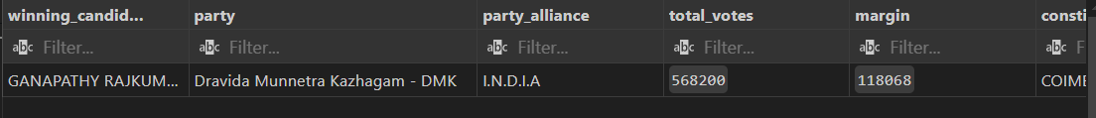

Distribution of EVM votes versus postal votes for candidates in a specific constituency  
  
 SELECT

    cd.Candidate,

    cd.Party,

    cd.EVM_Votes,

    cd.Postal_Votes,

    cd.Total_Votes,

    cr.Constituency_Name

FROM

    constituencywise_details cd

JOIN

    constituencywise_results cr ON cd.Constituency_ID = cr.Constituency_ID

WHERE

    cr.Constituency_Name = 'MATHURA'

ORDER BY cd.Total_Votes DESC;

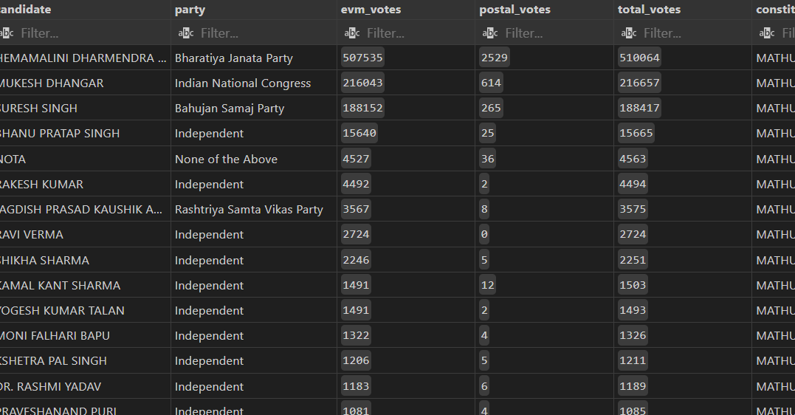  
  
parties won the most seats in s State, and how many seats did each party win  
  
SELECT

    p.Party,

    COUNT(cr.Constituency_ID) AS Seats_Won

FROM

    constituencywise_results cr

JOIN

    partywise_results p ON cr.Party_ID = p.Party_ID

JOIN

    statewise_results sr ON cr."Parliament Constituency"= sr."Parliament Constituency"

JOIN states s ON sr."State ID" = s."State ID"

WHERE

    s.state = 'Andhra Pradesh'

GROUP BY

    p.Party

ORDER BY

    Seats_Won DESC;

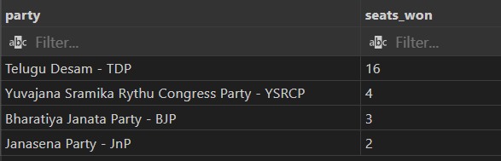

**The total number of seats won by each party alliance (NDA, I.N.D.I.A, and OTHER) in each state for the India Elections 2024**  
  
SELECT

    s.State AS State_Name,

    SUM(CASE WHEN p.party_alliance = 'NDA' THEN 1 ELSE 0 END) AS NDA_Seats_Won,

    SUM(CASE WHEN p.party_alliance = 'I.N.D.I.A' THEN 1 ELSE 0 END) AS INDIA_Seats_Won,

    SUM(CASE WHEN p.party_alliance = 'OTHER' THEN 1 ELSE 0 END) AS OTHER_Seats_Won

FROM

    constituencywise_results cr

JOIN

    partywise_results p ON cr.Party_ID = p.Party_ID

JOIN

    statewise_results sr ON cr."Parliament Constituency" = sr."Parliament Constituency"

JOIN

    states s ON sr."State ID" = s."State ID"

Group by

State_Name

ORDER BY

    s.State;

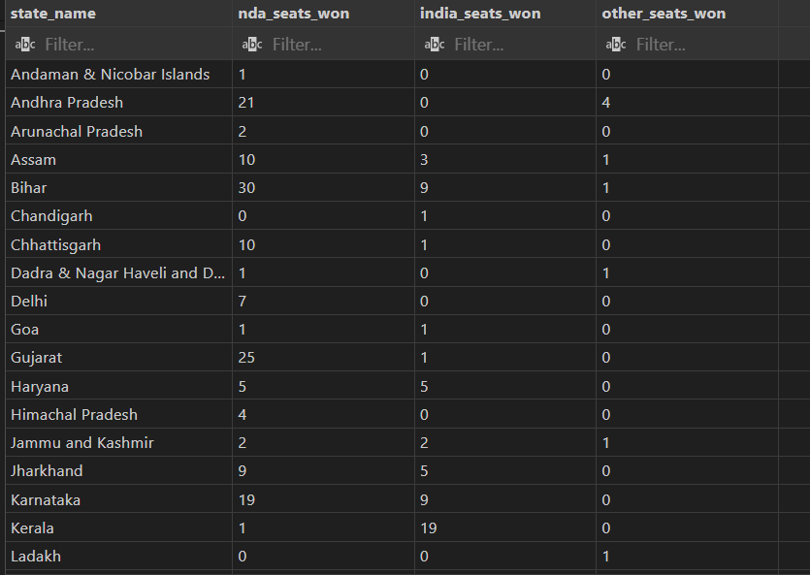  
  
  
**The highest number of EVM votes in each constituency**  
  
SELECT

    cr.Constituency_Name,

    cd.Constituency_ID,

    cd.Candidate,

    cd.EVM_Votes

FROM

    constituencywise_details cd

JOIN

    constituencywise_results cr ON cd.Constituency_ID = cr.Constituency_ID

WHERE

    cd.EVM_Votes = (

        SELECT MAX(cd1.EVM_Votes)

        FROM constituencywise_details cd1

        WHERE cd1.Constituency_ID = cd.Constituency_ID

    )

ORDER BY

    cd.EVM_Votes DESC

LIMIT 10;

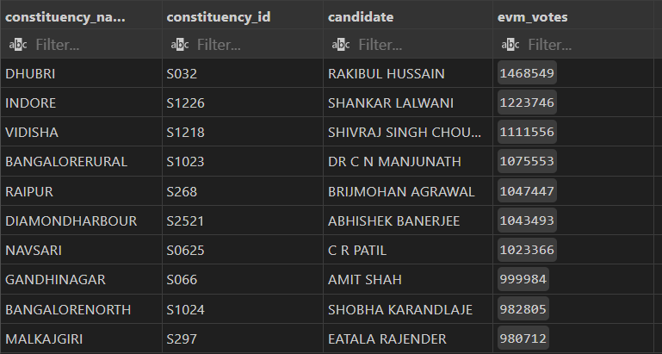  
  
  
candidate won and which candidate was the runner-up in each constituency of State for the 2024 elections  
  
WITH RankedCandidates AS (

    SELECT

        cd.Constituency_ID,

        cd.Candidate,

        cd.Party,

        cd.EVM_Votes,

        cd.Postal_Votes,

        cd.EVM_Votes + cd.Postal_Votes AS Total_Votes,

        ROW_NUMBER() OVER (PARTITION BY cd.Constituency_ID ORDER BY cd.EVM_Votes + cd.Postal_Votes DESC) AS VoteRank

    FROM

        constituencywise_details cd

    JOIN

        constituencywise_results cr ON cd.Constituency_ID = cr.Constituency_ID

    JOIN

        statewise_results sr ON cr."Parliament Constituency" = sr."Parliament Constituency"

    JOIN

        states s ON sr."State ID" = s."State ID"

    WHERE

        s.State = 'Maharashtra'

)

SELECT

    cr.Constituency_Name,

    MAX(CASE WHEN rc.VoteRank = 1 THEN rc.Candidate END) AS Winning_Candidate,

    MAX(CASE WHEN rc.VoteRank = 2 THEN rc.Candidate END) AS Runnerup_Candidate

FROM

    RankedCandidates rc

JOIN

    constituencywise_results cr ON rc.Constituency_ID = cr.Constituency_ID

GROUP BY

    cr.Constituency_Name

ORDER BY

    cr.Constituency_Name;

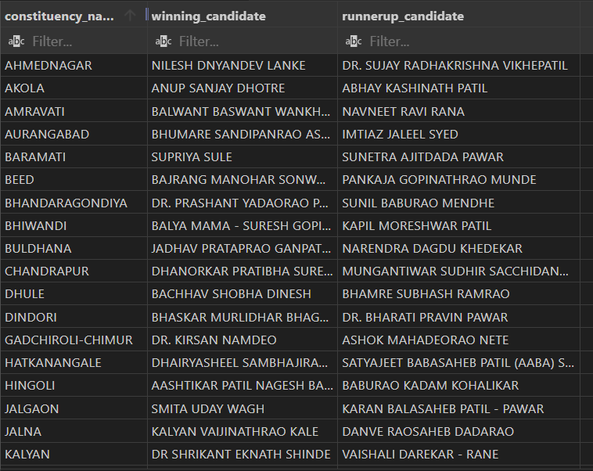

**For the state of Tamil Nadu, what are the total number of seats, total number of candidates, total number of parties, total votes (including EVM and postal), and the breakdown of EVM and postal votes?**  
  
SELECT

    COUNT(DISTINCT cr.Constituency_ID) AS Total_Seats,

    COUNT(DISTINCT cd.Candidate) AS Total_Candidates,

    COUNT(DISTINCT p.Party) AS Total_Parties,

    SUM(cd.EVM_Votes + cd.Postal_Votes) AS Total_Votes,

    SUM(cd.EVM_Votes) AS Total_EVM_Votes,

    SUM(cd.Postal_Votes) AS Total_Postal_Votes

FROM

    constituencywise_results cr

JOIN

    constituencywise_details cd ON cr.Constituency_ID = cd.Constituency_ID

JOIN

    statewise_results sr ON cr."Parliament Constituency" = sr."Parliament Constituency"

JOIN

    states s ON sr."State ID" = s."State ID"

JOIN

    partywise_results p ON cr.Party_ID = p.Party_ID

WHERE

    s.State = 'Tamil Nadu';

